

Service Business (2022) 16:77–98

https://doi.org/10.1007/s11628-022-00481-0

**EMPIRICAL ARTICLE**

**Research trends in digital transformation in the service**

**sector: a review based on network text analysis**

**Jin Sung Rha1 · Hong‑Hee Lee2**

Received: 5 November 2021 / Accepted: 29 January 2022 / Published online: 7 February 2022

© The Author(s), under exclusive licence to Springer-Verlag GmbH Germany, part of Springer Nature 2022

**Abstract**

Digital transformation has influenced value chain operations of both manufacturing and service firms. This study examined digital transformation in the service sector through network text analysis of 330 related articles published during the past 10 years. The selected papers’ keyword link relations were analyzed to create network maps of research topics, ranging from traditional to emerging ideas of research‑ers. Dominant research topics and their clusters were identified using centrality and community analyses, and research trends were identified. The results of this study will help researchers and practitioners in the relevant fields capture the overall pic‑ture of the field.

**Keywords** Research trends in the service sector · Service Business: An International Journal · Network text analysis

**1 Introduction**

Digitalization has accelerated innovation to a point never imagined before (Lee and Lim 2018). Businesses have been implementing digitalization to support flexible changes in operational processes, information systems, and society at large (Parvi‑ainen et al. 2017). Digitalization enables service innovations (Tronvoll et al. 2020) and has caused recent changes in the business environment of various industries (Kapadia and Madhav 2020). Therefore, digitalization, if well utilized, can help the enterprise develop dynamic capabilities for agility, flexibility, and resilience in delivering the products and services that customers want (Teece 2014; Lee and

* Hong‑Hee Lee   
 hlee9@stmarytx.edu

Jin Sung Rha   
jinsungrha@dankook.ac.kr

1 School of Business Administration, Dankook University, Yongin‑si 16890, South Korea

2 Greehey School of Business, St. Mary’s University, San Antonio, TX 78228, USA

Vol.:(0123456789) 1 3

|  |  |
| --- | --- |
| 78 | J. S. Rha, H.-H. Lee |

Trimi 2021). Thus, firms can utilize digital technologies to continuously improve their value proposition (Coreynen et al. 2020). Digitalization is also seen as a source of organizational sustainability, allowing firms to continuously pursue internal effi‑ciency and external opportunity to create value and increase the market share (Parvi‑ainen et al. 2017; Kamalaldin et al. 2020).

Unlike digitization, which means utilizing digital technologies, digitalization includes value creation for the customers after utilizing the technologies (Seyedg‑horban et  al. 2020). Digitalization is defined as “the use of digital technologies and digitized data to impact how work gets done, transform how customers and companies engage and interact, and create new digital revenue streams” (Strønen 2020). Recently, various digital technologies have triggered service business growth through digitalization or digital transformation (Gebauer et al. 2021). Major tech‑nologies for digitalization are AI, Internet of Things (IoT), cloud computing, and big data (Kretschmer and Khashabi 2020). IoT, cloud computing, and big data analyt‑ics, often considered as base technologies for digitalization, have enabled firms to explore new opportunities to execute customer‑oriented business models (Lee and Lim 2018; Frank et al. 2019; Paiola and Gebauer 2020). IoT has made various enti‑ties, from physical devices to software, connected with each other through networks. The data exchange in real‑time between the entities provides deep insights into mate‑rial and information flows in the supply chain. IoT, also known as Internet of Eve‑rything (IoE), helps construct sophisticated knowledge networks for value creation through real‑time communication (Lee and Lim 2018). Cloud services are the back‑bone of digital transformation because they help store and analyze large sets of data at reasonable cost (Abolhassan 2016). According to Statista.com (2021), the number of IoT‑connected devices is expected to reach more than 30 billion by 2025, from 11.7 billion in 2020. Big data analytics deals with “the use of advanced analytic techniques against very large, diverse big data sets that include structured, semi‑structured and unstructured data, from different sources, and in different sizes from terabytes to zettabytes” (IBM.com 2021). Since traditional database management systems are not powerful enough to handle big data, advanced technologies such as AI and IoT are deployed for the analysis. Many organizations rely on big data ana‑lytics to extract valuable information and knowledge from the data collected through various channels. Important topics on big data analytics such as storage capacity, visualization, and wireless sensor networks have attracted the attention of big data researchers (Choi et al. 2017). Using the document co‑citation analysis, Ardito et al. (2019) found four clusters representing big data analytics and management in the literature: (1) conceptual evolution of big data analytics, (2) management transfor‑mation by big data analytics, (3) effects of big data analytics on resource manage‑ment and performance, and (4) transformation of supply chain management by big data analytics (Ardito et al. 2019). Big data analytics facilitates the internal process, helps detect errors, and enhances customer engagement (Kretschmer and Khashabi 2020).

Digital transformation in the service sector has recently emerged as an impor‑tant research topic, and an increasing number of studies have been published in conference proceedings and journals. The present study analyzes the trends of the research on digital transformation by conducting network text analysis on the papers

1 3

|  |  |
| --- | --- |
| Research trends in digital transformation in the service sector:… | 79 |

that have recently been presented in conferences and published in academic jour‑nals to shed light on future directions of digital transformation in the service sector. Network text analysis examines semantic relations among keyword nodes by con‑structing matrices of co‑occurrences and presenting a visual form of a network (Lee and Su 2010). Unlike conventional studies that investigated research trends based on simple frequency analysis of research topics and methodologies used, this study analyzes the relationships among central research topics and keyword clusters of recently published papers on digital transformation in the service sector through net‑work text analysis using NetMiner4.0. This study is organized as follows. Section 2 reviews previous studies on digital transformation. Section 3 provides an overview of network text analysis and examines the published papers digital transformation in services that have been frequently cited. Section 4 summarizes the analysis results and proposes future research directions. Finally, Sect. 5 describes the implications of the results, limitations of the study and future research needs.

**2 Literature review**

**2.1 Digital transformation strategy**

Digital transformation should be an important part of corporate strategy since its effective implementation would have such significant impacts on organizational agil‑ity, flexibility, and resilience which in turn result in positive performance outcomes (Kretschmer and Khashabi 2020). For example, Amazon has used very effective and sophisticated big data analytics, which has been a major enabler of the firm’s suc‑cess in sales performance (Jannapureddy et al. 2019).

Digitalization helps establish high‑level collaboration with customers, which can generate new revenue sources (Scherer et al. 2017). The most significant benefit of E‑commerce is learning about customers over time, without needing to deploy addi‑tional channels to push products or services to them (Strønen 2020). Competitive E‑commerce service providers, such as Amazon.com and Alibaba.com, gather a vast amount of customer information about the relationship between age and access times or customer characteristics of a specific product. Kretschmer and Khashabi (2020) found digitalization helps enhance interaction with consumers. Companies need to unlearn inflexible product‑oriented strategies and balance product and ser‑vice assets to assure the transformation journey is smooth toward a comprehensive service mindset (Tronvoll et al. 2020).

Digitalization has helped companies develop and implement innovative business models (Hokkanen et al. 2021). Digitalization has attracted many knowledge work‑ers to handle cognitive tasks, for both business and society (Loebbecke and Picot 2015). According to Kretschmer and Khashabi (2020), digital transformation has guided changes in organizational structures through the evolution of internal pro‑cesses, which they labeled a strategic renewal. The digital transformation process in the service‑dominant age should be supported by the strategic shifts of organ‑izations. Tronvoll et al. (2020) suggested three facilitators of the shift: identifica‑tion, dematerialization, and collaboration. By identifying real‑time information, a

1 3

|  |  |
| --- | --- |
| 80 | J. S. Rha, H.-H. Lee |

company can make effective move from planning to making both short‑term and long‑term decisions that are most appropriate in the environment. The firm can transition from physical insufficiency to abundance and doing more with less, by dematerialization enabled by digital servitization. Collaboration among partners in a value chain allows the participants to develop horizontal relationships rather than constrained by vertical ones in the organization.

The digital transformation process presents many potential challenges as well as opportunities. However, many organizations encounter difficulties in changing their business models tailored to the transformation environment (Loebbecke and Picot 2015; Kretschmer and Khashabi 2020). Digitalization allows advanced data analyt‑ics, connectivity among products and services, and blurred boundaries among sup‑pliers, customers, competitors, and even markets (Porter et al. 2014). Many large organizations are tradition bound and afraid to abandon their existing arrangements, the transformation process becomes disjointed, thus making it difficult to develop desired business models. For this reason, flexible and innovative startups are gener‑ally more effective than their large counterparts in radically changing their business models even under budget constraints (Loebbecke and Picot 2015). In sum, digital transformation is rapidly becoming an imperative driver of competitive advantage in the rapidly changing market environment (Kretschmer and Khashabi 2020).

**2.2 Digital servitization**

Fierce competition and technological advances drive firms toward implementing a digital servitization strategy (Coreynen et al. 2020). Like digitalization, digital ser‑vitization requires organizations to make drastic changes in their business models and operations (Tronvoll et al. 2020). Many companies are increasing their service offerings through digital transformation. Mobidoo, a Korean venture firm, offers a secure and easy‑to‑use mobile payment service to credit card users, using encrypted inaudible sound waves. As the world adopts digital payment systems, the users are increasingly concerned about security issues and compatibility with international standards (Mridha et al. 2017). For another example, wearable devices in healthcare such as smart health trackers and blood pressure monitors have helped deliver vari‑ous healthcare services through smartphone apps (Lee and Lee 2020a). Firms are moving from the primary focus on goods they offer to integrated ecosystems with services, and this trend appears prevalent in both manufacturing and service indus‑tries (Coreynen et al. 2020).

The term “servitization” was coined by Vandermerwe and Rada (1988) and digi‑tal servitization is defined as “the transition toward smart product‑service‑software systems that enable value creation and capture through monitoring, control, optimi‑zation, and autonomous function” (Coreynen et al. 2020). The servitization trend has been embraced by various disciplines with different labels such as the product‑service system, transition from product to solutions, hybrid offerings, and others (Paiola and Gebauer 2020). Digitalization is the main driver of servitization. Mar‑tín‑Peña et al. (2018) argued that any firm interested in adopting servitization must first consider implementing digital transformation.

1 3

|  |  |
| --- | --- |
| Research trends in digital transformation in the service sector:… | 81 |

Digital servitization is defined as “the transformation in processes, capabili‑ties, and offerings within industrial firms and their associated ecosystems to pro‑gressively create, deliver, and capture increased service value arising from a broad range of enabling digital technologies” (Sjödin et al. 2020). Digital services activate relational interactions with customers to enhance service quality, brand loyalty, and customer satisfaction (Kamalaldin et al. 2020). As digital technology adoption has enabled product‑oriented companies to develop service‑oriented business models through digital servitization. To benefit from digitalization, value chain stakehold‑ers are shifting their attention from the product‑oriented transactional model to the service‑oriented relational arrangement (Kamalaldin et al. 2020).

Digital servitization has two organizational perspectives, a front‑end perspective and a back‑end one (Kryvinska et al. 2020). The front‑end servitization supports deeper interactions with customers while back‑end servitization helps the organiza‑tion achieve operational efficiency and improved resource allocation (Coreynen et al. 2017). To be competitive in the dynamic marketplace, a critical resource is firm’s capacity to collect and analyze data that are essential for developing competitive advantage (Paiola and Gebauer 2020). Coreynen et al. (2020) also suggested sepa‑rating organizational efforts that are directed toward exploitation allied with digital servitization and those focused on exploration. According to that study, explora‑tion seems more effective when the two efforts are made together even though both exploitation and exploration support digital servitization.

**3 Methodology**

**3.1 Network text analysis**

This study performed a network text analysis to identify the research trends regard‑ing digital transformation in the service industry. Network text analysis encom‑passes text mining and network analysis. Text mining is used to analyze and obtain meaningful information from unstructured textual data. Network analysis consists of a network of nodes and links based on data matrices and is used to determine the network structure and effect of each node. By combining these analytical tech‑niques, network text analysis helps obtain key information from texts and build vari‑ous networks based on co‑occurrence matrices (Ferstl et al. 2008).

Previous research trend analyses classified the articles based on the research‑ers’ subjectivity or sorted them manually based on the applied methodologies and theories (Rha 2020). However, network text analysis can help analyze the given texts exploratively. Therefore, this method is advantageous in that it can quantify and explain the research trends objectively, through using the text data of research articles.

Recently, many studies in various business fields explored research trends using network analysis. Fahimnia et al. (2015a, b) searched published articles on supply chain management on Scopus and built document, citation, and co‑citation networks. They also used cluster and Page Rank analysis to identify key researchers in subfields over time and determined influential articles in the

1 3

|  |  |
| --- | --- |
| 82 | J. S. Rha, H.-H. Lee |

network using the citation index. Feng et al. (2017) analyzed the clusters of key research articles by building a co‑citation network of articles on corporate social responsibility, extracted the main keywords by building a co‑word network, and built the clusters of subtopics. Lee and Rha (2018) developed a network using keywords as nodes extracted from articles published in Service Business: An International Journal for 10 years and analyzed the trends in subtopics in service business areas by calculating the degree of centrality and betweenness centrality.

**3.2 Procedures of network text analysis**

Network text analysis is generally conducted based on the following procedures (Pyun and Rha 2021). First, a database is selected to search the research arti‑cles for analysis. This study used Scopus, a widely known academic database, to search the articles. Scopus encompasses most major articles in business and social science fields. Thus, it is suitable for capturing the research trends in spe‑cific subfields (Rha 2020; Yu and Rha 2021). Second, keywords were extracted from the articles searched on the database, after which they were cleansed. On Scopus, indexed keywords and those presented by researchers can be extracted from the selected articles. This study mostly used the keywords presented by authors. After keyword extraction, we performed the following additional steps: supplementing keyword omissions, unifying the terms, and deleting useless words. The whole process is explained comprehensively in the Results section. Third, using the extracted keywords, their frequency in the articles was trans‑formed into a matrix to construct a two‑mode network comprised articles and keyword nodes. A two‑mode network refers to a network with two dimensions of nodes. In a two‑mode network, articles and keywords are connected with links, rather than with another article or another keyword. Therefore, relations among keywords cannot be analyzed directly with just two‑mode networks. Fourth, the two‑mode network comprised articles and keywords was transformed into a one‑mode network comprised only keyword nodes. Network transformation is based on the co‑occurrence of keywords. Suppose article A presents keywords a and b; article B presents keywords a, b, and c; and article C presents keywords a, b, and d. Then, keywords a and b are likely to be in co‑occurrence, hence highly correlated. In this case, keyword nodes a and b are connected with a link when building a keyword network. This study used the cosine similarity algorithm to transform a two‑mode network of articles and keywords into a one‑mode net‑work with just keywords. This study conducted centrality and cluster analyses to identify the characteristics of keyword nodes. Degree centrality and between‑ness centrality were also analyzed. Keywords with a high degree of centrality indicate that the relevant field is the most actively researched, while those with a high betweenness centrality indicate that the keywords are highly expanda‑ble. Using cluster analysis, research topics can be grouped based on the net‑work structure. The procedures of network text analysis performed in this study is shown in Table 1.

1 3

|  |  |
| --- | --- |
| Research trends in digital transformation in the service sector:… | 83 |

**Table 1** Procedures of network text analysis

|  |  |
| --- | --- |
| Analytical procedures | Descriptions |

1. Collect data

2. Extract and cleanse keywords

3. Build a two‑mode network comprised articles and keywords

4. Build a one‑mode network comprised keyword nodes

5. Conduct keyword network analysis

Selecting a database for searching articles and col‑ lecting article data using search words   
This study used Scopus

Extracting keywords from collected article data Cleansing extracted keywords   
Preprocessing keywords such as unifying terms and deleting useless words

Forming a matrix based on keywords occurring in articles   
Building a two‑mode network based on the matrix

Transforming the two‑mode network into a one‑ mode network comprised only keywords   
Links in a keyword network are connected depend‑ ing on the co‑occurrence of the words   
This study used the cosine similarity algorithm in transformation

Analyzing the degree centrality and betweenness centrality of keyword nodes in the keyword   
 network   
Analyzing cluster formations of keywords based on the network structure   
Research topics are grouped using cluster analysis This study conducted a cluster analysis according to the method provided by Blondel

**4 Results**

**4.1 Articles selected for analysis**

This study collected and analyzed published articles on digitalization in the service industry. We used Scopus to search for the relevant articles. As shown in Table 2, various search words were entered to analyze the related articles. Articles were

|  |  |  |
| --- | --- | --- |
| **Table 2** Search words | Searching word | Number  of articles |
|  | Service and digital transformation | 220 |
| Service and digitalisation | 141 |
| Service and digitalization | 132 |
| Service business and digital transformation | 72 |
| Service management and digital transformation | 72 |
| Service management and digitalisation | 35 |
| Service management and digitalization | 35 |
| Service business and digitalisation | 32 |
| Service business and digitalization | 32 |

1 3

|  |  |
| --- | --- |
| 84 | J. S. Rha, H.-H. Lee |

selected using the search words that are related to the keywords presented by the authors or indexed by Scopus. The research areas were limited to “Business, Man‑agement, and Accounting” and “Decision Science”. Further, only peer reviewed articles published in English, including those in journals or presented in conferences or symposiums, were selected for analysis. Three hundred and thirty articles were selected as the study sample, excluding those searched redundantly using various search words.

Figure 1 summarizes 330 articles by year of publication. Since 2016, the number of studies on digital transformation began to accelerate. This study searched only articles published up to June 2021. Table 3 shows major journals that published the articles in our sample.

**4.2 Preprocessing to build a keyword network**

A total of 1126 keywords were collected from 330 articles in our research sample. Keywords presented in the articles were used preferentially. Further, in case the key‑words were omitted, some keywords were extracted from the article titles as done by previous studies (Rha 2020). Cleansing was further conducted. Of the 1126 key‑words, some were similar in meaning but expressed in different ways. For example, “Internet of Things” and “IoT” carry the same meaning and were therefore unified into “IoT”, and “Artificial Intelligence”, and “AI” as “AI”. Similarly, “Healthcare Industry”, “Health Services”, “E‑Healthcare”, and “M‑Healthcare” were all dealt with “Healthcare” and were therefore unified as “Healthcare”. When keyword cleansing was necessary according to the content of the article, two researchers in the service field were consulted.

����������������

���

|  |  |
| --- | --- |
| ����������� �� �� �� � |  |

���� ���� ���� ���� ���� ���� ���� ���� ���� ���� ���� ����

**Fig. 1** The number of articles by year

1 3

|  |  |
| --- | --- |
| Research trends in digital transformation in the service sector:… | 85 |

**Table 3** Journals publishing articles on service digital transformation

|  |  |
| --- | --- |
| Source title | Number  of articles |
| Lecture Notes in Business Information Processing  IFIP Advances in Information and Communication Technology Smart Innovation, Systems and Technologies  Technological Forecasting and Social Change  Journal of Business Research  International Journal of Supply Chain Management  Journal of Services Marketing  Technology in Society  TQM Journal  Service Business | 26  22  15  9  5  4  4  4  4  3 |

This study used “Service”, “Digitalization”, and “Digital Transformation” as search keywords. As these keywords were presented in most articles, they could not be considered as influential keywords despite their high frequency and cen‑trality in network analysis. Further, it is more important to analyze the keywords that are linked to digital transformation than digital transformation itself as this study analyzed articles on digital transformation in the service industry. There‑fore, this study eliminated “Service”, “Digitalization”, and “Digital Transforma‑tion” from the gathered keywords. Ultimately 1049 keywords were used in net‑work analysis through keyword cleansing. Of the 1049 keywords, those with a high frequency were “Innovation”, “Industry 4.0”, “Servitization”, “Business Model”, “IoT”, “E‑government”, “Financial Services”, “Healthcare”, and “Big Data”. Fig.  2 shows a word cloud created based on keyword frequency, with higher frequency shown in bigger texts.

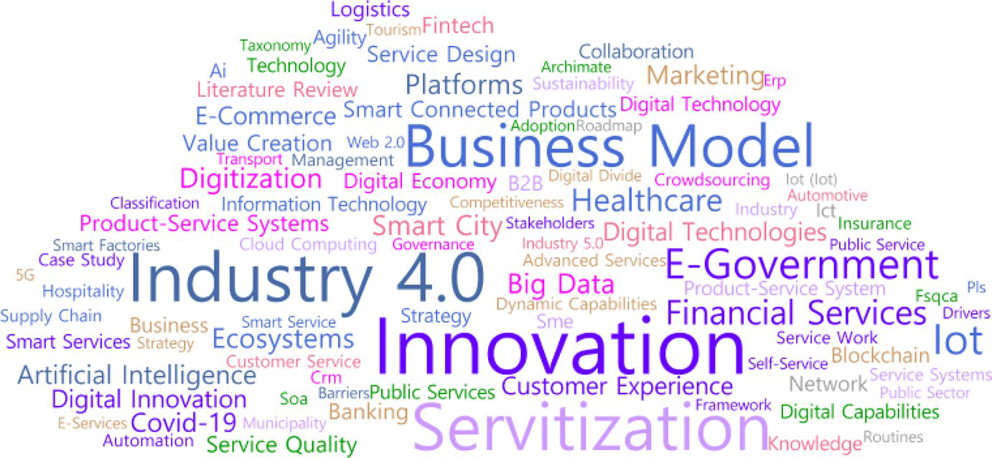

**Fig. 2** Word cloud

1 3

|  |  |
| --- | --- |
| 86 | J. S. Rha, H.-H. Lee |

**4.3 Building two‑mode and one‑mode networks**

By collecting keywords, a matrix is naturally formed with two dimensions: arti‑cles and keywords. The keywords presented in each article were used. The fre‑quency of each keyword of an article could be either “1”, or “0” if there was no keyword. If a certain keyword occurred in a certain article, the value between the two would be “1”. Thus, these two are connected with a link in the network. This is how a two‑mode network is comprised article nodes and keyword nodes. In this case, article nodes are not linked with each other, neither are keyword nodes. Figure  3 shows a two‑mode network comprised articles and keywords, with most articles and keywords forming a huge network. This indicates that most articles researched related topics. A small number of other articles had keywords that were not presented by other articles. These articles, therefore, were separated from the two‑mode network.

To transform the two‑mode network comprised articles and keywords into a one‑mode network comprised keyword nodes only, this study calculated cosine similarity as shown in Eq. 1. This study included only the keywords that had the

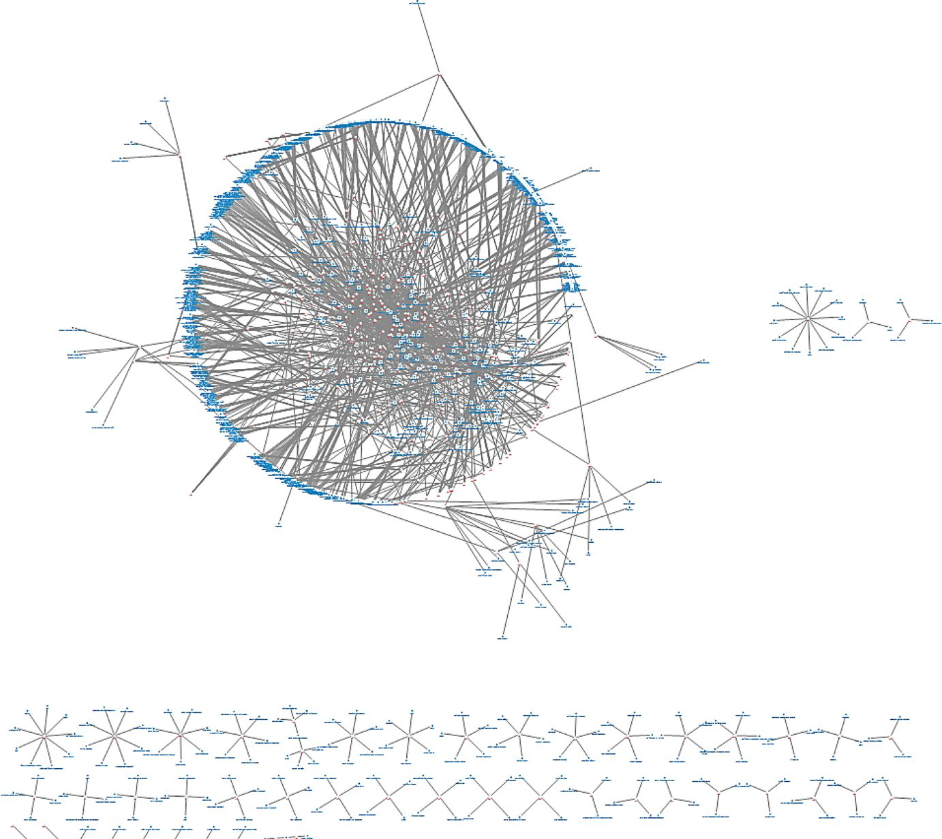

**Fig. 3** Two‑mode network between keywords and research articles

1 3

|  |  |
| --- | --- |
| Research trends in digital transformation in the service sector:… | 87 |

occurrence frequency of 2 or above when developing a one‑mode network. The cut off value of cosine similarity was 0.2.

|  |  |  |  |  |
| --- | --- | --- | --- | --- |
| Cosine similarity = | ∑*n k*=1*CikCjk* | | , | (1) |
| �∑*n k*=1*C*2 *ik* | �∑*n k*=1*C*2 *jk* |

where *Cik* = number of occurrences of keyword *i*, *Cjk* = number of occurrences of keyword *j*.

The keyword network is shown in Fig. 4. Keyword nodes in the one‑mode key‑word network are connected with links when they occur in multiple articles, as the higher the co‑occurrence the greater the cosine similarity. The locations of keyword nodes in the network are insignificant; they are located close when they are relevant. Moreover, the links have no weights or directions.

**4.4 Centrality analysis**

Centrality analysis was conducted using the keyword network. This study analyzed degree centrality and betweenness centrality. Degree centrality shows how many

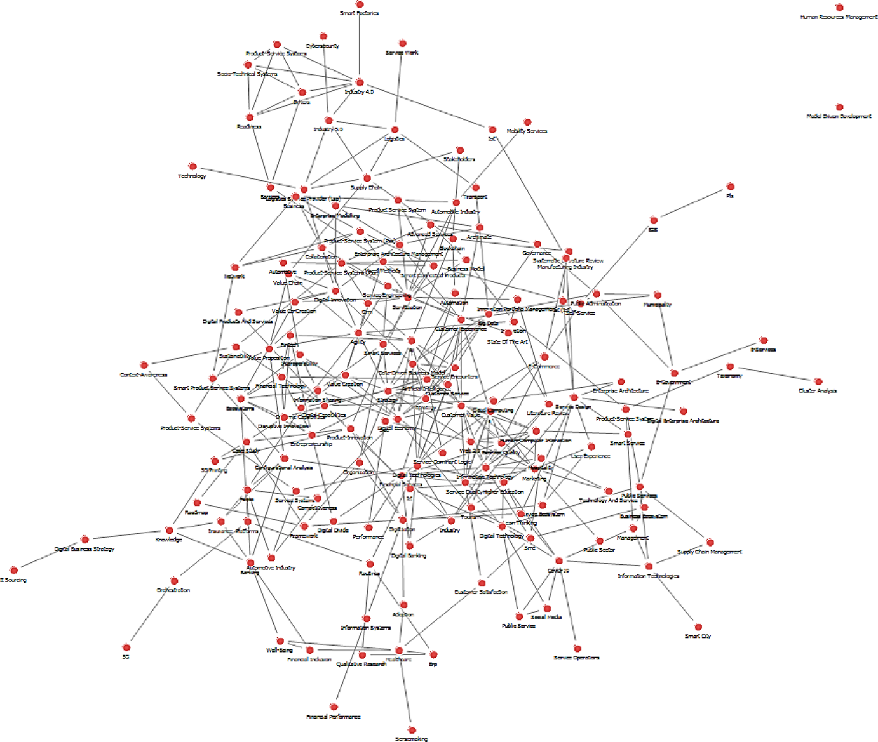

**Fig. 4** One‑mode network among keywords

1 3

|  |  |
| --- | --- |
| 88 | J. S. Rha, H.-H. Lee |

links a particular node has with other nodes in the network. Nodes with high degree centrality are actively linked to many other nodes in the network, indicating their keywords are closely related to subtopics that are most actively examined. Between‑ness centrality increases when a particular node is frequently located on the paths between different nodes. Nodes with high betweenness centrality mediate other nodes and are therefore analyzed as keywords connecting subtopics or expanding concepts in the keyword network. Degree centrality and betweenness centrality can be calculated as shown in Eqs. 2 and 3.

|  |  |  |  |  |  |  |  |
| --- | --- | --- | --- | --- | --- | --- | --- |
| Degree centrality = | ∑ Weight of incident links Number of nodes − 1 | | | | | , | (2) |
| Betweenness centrality = | | ∑*j<kgjk*(*ni*)∕*gjk* | | | , | (3) |
|  | (*g*−1)(*g*−2) |  |
|  | 2 |  |  |  |  |

where *gjk* = the number of shortest paths that connect nodes *j* and *k*, *gjk*(*ni*) = the num‑ber of paths that passthrough node *i* among the shortest paths that connect nodes *j* and *k*, [(*g* − 1)(*g* − 2)/2] = the number of all node pairs not including *ni*).

Table 4 shows the results of the degree centrality analysis. The keywords with a high degree centrality were “Business Model”, “Servitization”, “Innovation”, “Cus‑tomer Experience”, “Industry 4.0”, “Big Data”, and “Business Ecosystem”. Many studies on digital transformation in the service industry explored the development and application of new business models in line with digital transformation. Moreo‑ver, many studies were on servitization based on sensing, data storage and analysis technology as well as pursuing innovation through digitalization. They examined business ecosystems for developing new business models and innovation.

Table 5 shows the results of the betweenness centrality analysis. They are gen‑erally similar to the results of the degree centrality analysis. However, keywords such as “Banking”, “Financial Services”, and “Healthcare” showed a relatively high betweenness centrality. This implies that many studies on digital transformation in the service industry were focused on topics related to finance and healthcare.

A cluster analysis was conducted using the structural characteristics of the key‑word network. The process was based on the algorithm of Blondel et al. (2008) and provided by NetMiner. Keywords with high cohesion can be placed in one group through cluster analysis. Therefore, clusters comprised keyword nodes can be ana‑lyzed as subtopics on digital transformation in the service industry. Consequently, 6 clusters were formed as shown in Fig. 5. Table 6 shows the main keywords of each cluster.

The first cluster is about analyzing new ecosystems by business firms regarding the digitalization of services and new collaborative mechanisms. Further, the main keywords were “Ecosystem”, “Platforms”, “Value Creation”, “Fintech”, “Informa‑tion Sharing”, and “Collaboration”. Articles related to the first cluster among our sample of 330 articles are as follows. Liu (2020) argued that real‑time information sharing and co‑value creation between firms have become important in digitalized services, and that it is necessary to consider a new business ecosystem based on new

1 3

|  |  |  |
| --- | --- | --- |
| Research trends in digital transformation in the service sector:… | | 89 |
| **Table 4** Results of the degree centrality analysis | Keyword | Degree centrality |
| 0.204819  0.186747  0.144578  0.144578  0.138554  0.138554  0.132530  0.126506  0.120482  0.114458  0.114458  0.096386  0.090361  0.090361  0.090361  0.084337  0.084337  0.084337  0.078313  0.078313  0.072289  0.072289  0.072289  0.072289  0.072289  0.072289  0.066265  0.066265  0.066265  0.066265  0.066265  0.066265  0.060241  0.054217  0.054217  0.054217  0.054217  0.054217  0.054217 |
| Business model  Servitization  Innovation  Customer experience  Industry 4.0  Big Data  Digital technologies  Business ecosystems  Customer value  Financial services  Strategy  Platforms  AI  Information technology  Digital economy  Agility  E‑commerce  Artificial intelligence  Covid‑19  Marketing  Healthcare  Digitization  Service quality  IoT  Data‑driven business model  Strategy  Service design  E‑government  Digital innovation  Value creation  Customer service  Service encounters  Banking  E‑service quality  Smart city  Web 2.0  Product‑service systems (PSs)  Fintech  Sustainability | |

1 3

|  |  |  |
| --- | --- | --- |
| 90 |  | J. S. Rha, H.-H. Lee |
| **Table 5** Results of the  betweenness centrality analysis | Keyword | Node between‑ ness centrality |
|  | Servitization | 0.132740 |
| Business model | 0.128815 |
| Big data | 0.111129 |
| Innovation | 0.106020 |
| Industry 4.0 | 0.081340 |
| Customer experience | 0.071739 |
| E‑government | 0.066751 |
| Business ecosystems | 0.057978 |
| Digital technologies | 0.057654 |
| AI | 0.048113 |
| Banking | 0.044702 |
| Financial services | 0.042525 |
| Platforms | 0.042069 |
| Digitization | 0.038547 |
| IoT | 0.035480 |
| Healthcare | 0.034062 |
| Covid‑19 | 0.033905 |
| Service design | 0.028652 |
| Strategy | 0.025578 |
| Governance | 0.025522 |
| Smart city | 0.025319 |
| Knowledge | 0.025103 |
| Customer value | 0.024521 |
| E‑commerce | 0.024467 |
| Open data | 0.023658 |
| Digital economy | 0.023528 |
| Digital innovation | 0.022318 |
| Marketing | 0.021301 |
| ICT | 0.020711 |
| Logistics | 0.019021 |
| Supply chain | 0.017903 |
| Blockchain | 0.017501 |
| Sustainability | 0.016659 |
| 3D printing | 0.015144 |

collaboration methods as firms depend more on one another. Endres et al. (2021) proved that digital innovation in the process of new software product development promotes entrepreneurial ecosystems and improves performance.

The second cluster is about major digital technologies that drive the digital transformation of services. The main keywords were “Blockchain”, “Industry 4.0”, “IoT”, “Product Services Systems”, and “Cybersecurity”. Li et al. (2020) analyzed

1 3

|  |  |
| --- | --- |
| Research trends in digital transformation in the service sector:… | 91 |

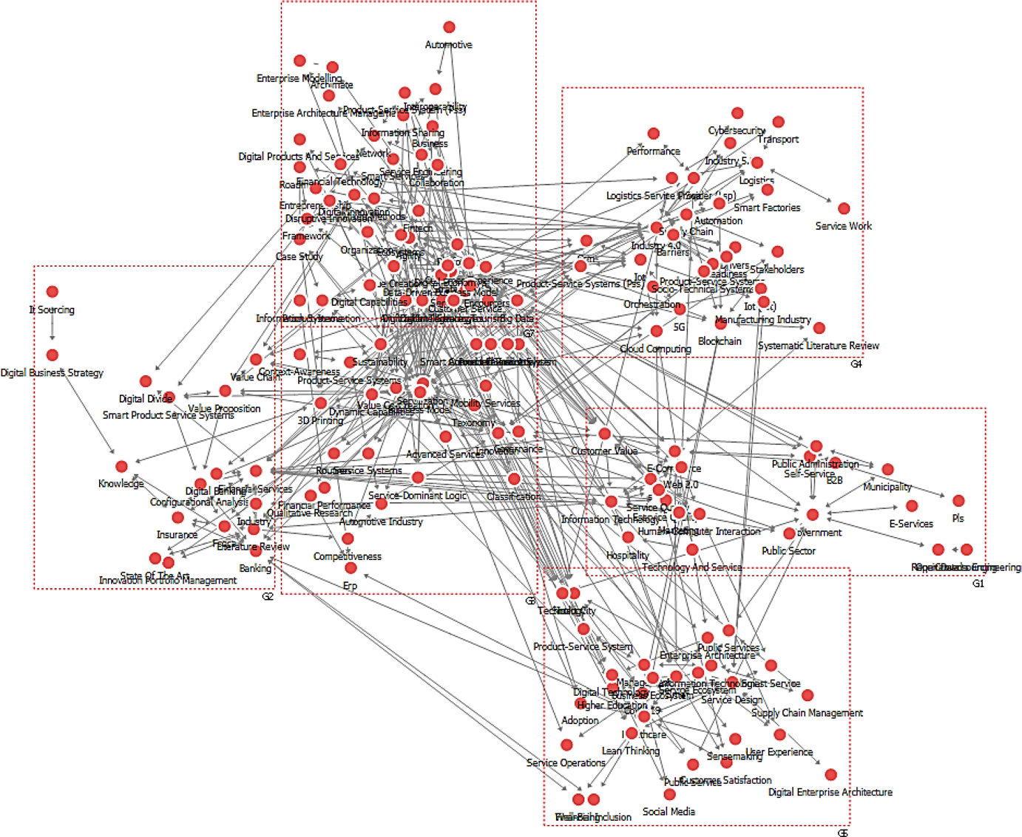

**Fig. 5** Keyword network clustering analysis

the rapid increase in the application of blockchain technology in financial service and conducted a scientometric analysis, which showed that much attention was focused on legal matters and the security advantage of blockchain. The data on a blockchain is secured through cryptography, the decentralized peer‑to‑peer network infrastructure, and distributed ledger technology. Sestino et al. (2020) indicated that IoT is one of the most important technologies in the digitalization of services as customer behavior and interests can be databased and identified on a real‑time basis. The third cluster is about the acceleration of digital transformation owing to COVID‑19 and the digitalization of the healthcare industry. The main keywords were “COVID‑19”, “Healthcare”, “SME”, and “Smart City”. Rapaccini et al. (2020) conducted a survey and found that the COVID‑19 pandemic accelerated digital ser‑vitization and caused service providers to concentrate their competencies on devel‑oping new products based on digital technology. Denicolai and Previtali (2020) found that digital transformation in the healthcare industry drives the development of precision medicine, increases the intensity of collaboration among organizations in the healthcare value chains, and drives the optimization of treatment performance and cost reduction by promoting information sharing in the ecosystem.

The fourth cluster is about the development and application of new business models as an outcome of digital transformation in the service industry and servitiza‑tion using digital technologies. The main keywords were “Dynamic Capabilities”,

1 3

|  |  |  |  |  |  |  |  |  |  |
| --- | --- | --- | --- | --- | --- | --- | --- | --- | --- |
| 92 | **Table 6** Keywords by cluster | Description | Analyzing new ecosystems among firms about digitalization of services  Studies on new collaborative mechanisms  Studies on major digital technologies that lead to digital transformation of  services  Studies on the acceleration of digital transformation owing to COVID‑19  Studies on digitalization in the healthcare industry  Studies on the development and application of new business models owing to  digital transformation in the service industry  Studies on servitization using digital technologies  Importance of dynamic capabilities to survive in a new digital environment | | | | Studies on E‑government, E‑commerce, and E‑services that drove digitalization  of services | Studies on the digitalization of financial business, a typical service industry | J. S. Rha, H.-H. Lee |
| Main keywords | Ecosystem, platforms, value creation, fintech, information sharing, collabora‑ tion  Blockchain, industry 4.0, IoT, product services systems, cybersecurity | | COVID‑19, healthcare, SME, smart city | Dynamic capability, servitization, value co‑creation, business model | E‑government, E‑commerce, E‑services, marketing | Financial services, banking, insurance |
| Cluster | 1 | 2 | 3 | 4 | 5 | 6 |

1 3

|  |  |
| --- | --- |
| Research trends in digital transformation in the service sector:… | 93 |

“Servitization”, “Value Co‑Creation”, and “Business Model”. Volberda et al. (2021) argued that unlike traditional business models, digital transformation enables new business models for value co‑creation with partners or customers. Here, dynamic capabilities are important for adapting to the fast changing environment and break‑ing free from the barriers of conventional methods and rules. Payne et al. (2021) explained that the diversification of services that can be aligned with products in the era of digital transformation enables all kinds of innovation by providing new cus‑tomized value to customers based on service‑oriented business models.

The fifth cluster is about E‑government, E‑commerce, and E‑services that drove the digitalization of services. The main keywords were “E‑Government”, “E‑Com‑merce”, “E‑Services”, and “Marketing”. Loukadounou et al. (2020) showed that the Greek government increased the citizens’ satisfaction with administrative services and also reduced related costs through digital transformation of administrative pro‑cesses. Case (2019) conducted a case analysis on B2B firms and discovered that digital transformation resulted in considerable changes in E‑commerce among the firms studied. Case further found that the level of customer experience anticipated by B2B buyers through E‑commerce had increased substantially.

The sixth cluster is about the digitalization of financial business. The main key‑words were “Financial Services”, “Banking”, and “Insurance”. Niemand et  al. (2021) showed that banks with entrepreneurship and a strategic vision for digital transformation can improve their performance based on digitalization. In the same context, Breidbach et al. (2019) argued that digitalization does not guarantee better performance in financial business; rather, it is necessary to examine various man‑agerial options, such as orchestration with existing services, effectively executing safety measures for security, assessing the performance of new financial services and value co‑creation efforts with customers.

**5 Discussion and conclusion**

This study identified the research trends of digital transformation in the service industry through network text analysis. Today, organizations strive to become agile organizations that are adaptable to the dynamic business environment, as customers are increasingly demanding various forms of new services in convergence with the digital media (Lee and Lim 2018). Thus, there has been an increasing number of studies on relevant topics. This study searched 330 articles on Scopus and used them to conduct a network analysis. The results of the centrality analysis using the key‑word network can be summarized as follows. The most actively studied subtopics in relation to digital transformation in the service industry were “Business Model”, “Ecosystem”, “Servitization”, and “Customer Experience”. Digital transformation enables firms to collaborate with all of their stakeholders for value co‑creation. This naturally leads them to develop new business models and concentrate on creating and operating new business ecosystems with partners and customers. Moreover, as the development of digital technologies has enabled product‑oriented firms to develop service‑oriented business models, they began to focus on digital servitiza‑tion. Value creation through new customer experience also became an important

1 3

|  |  |
| --- | --- |
| 94 | J. S. Rha, H.-H. Lee |

organizational strategy. Many studies in our research sample dealt with healthcare and financial services, as identified by the betweenness centrality analysis.

This study identified major topics of research on digital transformation in the ser‑vice industry through cluster analysis of the keyword network. The identified top‑ics were classified into six groups. The first cluster was about building new busi‑ness ecosystems for digitalization. Whereas digitization is the process of converting analog to digital, digitalization is the transformation process of making business processes over to use digital technologies (Gobble 2018). Many studies showed that digitalization in the service industry requires new management procedures and prac‑tices, demanding significant changes in organizational structure and culture (Sklyar et al. 2019; Pelletier and Cloutier 2019; Liu and Guo 2021; Endres et al. 2021). The second cluster included studies on technologies that are prevalently used in digi‑tal transformation, mostly Industry 4.0 technologies including IoT and blockchain. Many researchers have pointed out that IoT and blockchain technologies enable service providers to enhance monitoring, traceability, and full transparency over business processes with secure network platforms (Chehri and Jeon 2019; Rosete et al. 2020; Li et al. 2020). Because of these advantages, the market size of digital healthcare, fintech, and other untact services are expected to grow sharply (Lee and Lee 2020b). The third cluster showed that the COVID‑19 pandemic has accelerated digitalization in all social sectors, including the service industry and the healthcare area particularly. Even though face‑to‑face care plays a critical role in the current healthcare system, digital healthcare is suggested as an alternative face‑to‑face with a virtual visit to prevent infection and accelerate telemedicine services in the COVID‑19 era (Yamamoto 2021; Tortorella et al. 2021). Many studies maintained that service organizations are speeding up the adoption of digital transformation to respond quickly and decisively to the COVID‑19 pandemic era with resilience (Bar‑tsch et al. 2020; Agostino et al. 2021; Abdel‑Basset et al. 2021). The fourth clus‑ter highlighted that digital transformation led to the development of new business models in the service industry. Further, various studies were conducted on the topic of digital servitization. Digital servitization creates new innovative services such as add‑on services to smart product‑service systems, enabling organizations to sense, seize, and reconfigure new business opportunities (Linde et al. 2021a). Previous lit‑erature pointed out that digital servitization allows service organizations to build a platform for better interactions with customers, improving data collection, storage, analysis, and utilization (Sklyar et al. 2019; Linde et al. 2021b). The fifth cluster was about E‑government and E‑commerce that drove digitalization in the service industry even before digital transformation. E‑government systems aimed at provid‑ing more responsive and efficient services to the public with digital technologies, enhancing citizens’ trust and confidence in government (Uyar et al. 2021). Likewise, E‑commerce has provided customers with a personalized shopping experience and broken down the barriers of time, place, and space (Ameen et al. 2021). The articles in this cluster indicate that various managerial insights in conventional E‑service are important and they need to be finetuned to be suitable for the digital era. The final cluster was about digital transformation in the financial industry. Even though COVID‑19 crisis has accelerated the digital transformation, there are some barriers in adoption of digital transformation in the financial industries such as functional

1 3

|  |  |
| --- | --- |
| Research trends in digital transformation in the service sector:… | 95 |

and psychological barriers (Santos and Ponchio 2021). Functional barriers include product value and risk related to product usage, and psychological barriers are asso‑ciated with the tradition and norms of the person (Mani and Chouk 2018). Many articles not only focused on the importance of fintech and smart banking services but also argued that operational excellence is imperative for maximizing customer experience and security improvement for the successful digital transformation in the financial industry.

This study provides several significant contributions. First, it quantified and ana‑lyzed the research trends of digital transformation in the service industry using only those articles with unstructured text data. Using network text analysis, this study identified major research topics dealing with digital transformation in the service industry. There has been no systematic literature review done on digital transforma‑tion in the service industry. The results of this study will help researchers in the rele‑vant fields capture the overall picture of the field. Second, the research trend analysis conducted in this study also reveals the topics that need thorough future research. Despite the extensive scope of the service industry, many studies in our sample focused on healthcare and financial services, indicating the accelerating importance of these services. The results of our study also found that further research on the digitalization of other service areas are needed, such as hospitality and tourism, avi‑ation, and logistics. Moreover, many studies briefly explained the impact of COVID‑19 on the digitalization of services. As the COVID‑19 pandemic has become the new normal, it is necessary to conduct systematic research on how the post COVID‑19 era will affect digitalization in the service industry. In addition, more research is needed on new service strategies in the digital era (Lee and Trimi 2021). Moreover, service organizations should pursue strategic innovations for new business models and “untact” technologies such as AI, robots, IoT, and big data (Lee and Lee 2020b). Thus, it is necessary to carry out research on customer‑centric service strategies, convergence of disruptive digital technologies and services, and service innovations that can create new value and competitive advantage in the digital era.

This study has the following limitations. First, the research sample we used in this study may have omitted some relevant articles for analysis as we used only Scopus rather than multiple databases for article selection. Moreover, only the articles that are directly related to digital transformation in the service industry were searched. Second, this study analyzed articles based on the keyword network analysis, while further analysis can be done based on citations, co‑citations, and researcher net‑works. These limitations provide opportunities and directions for future research.

**References**

Abdel‑Basset M, Chang V, Nabeeh NA (2021) An intellig[ent framework using disruptive technologies fo](https://doi.org/10.1016/j.techfore.2020.120431)r COVID‑19 analysis. Technol Forecast Soc Change. [https:// doi. org/ 10. 1016/j. techf ore. 2020. 120431](https://doi.org/10.1016/j.techfore.2020.120431) Abolhassan F (ed) (2016) The drivers of digital transform[ation: why there’s no way around the cloud, 1](https://doi.org/10.1016/j.techfore.2020.120431)st edn. Springer, New York   
Agostino D, Arnaboldi M, Lema MD (2021) New development: COVID‑19 as a[n accelerator of digital](https://doi.org/10.1080/09540962.2020.1764206) [transformation in public](https://doi.org/10.1080/09540962.2020.1764206) service delivery. Public Money Manage 41:69–72. [https:// doi. org/ 10. 1080/](https://doi.org/10.1080/09540962.2020.1764206) [09540 962. 2020. 17642 06](https://doi.org/10.1080/09540962.2020.1764206)

1 3

|  |  |
| --- | --- |
| 96 | J. S. Rha, H.-H. Lee |

Ameen N, Tarhini A, Shah M, Madichie NO (2021) [Going with the flow: smart shopping](https://doi.org/10.1108/JSM-02-2020-0066) malls and omnichannel retailing. J Serv Mark 35:325–348. [https:// doi. org/ 10. 1108/ JSM‑ 02‑ 2020‑ 0066](https://doi.org/10.1108/JSM-02-2020-0066) Ardito L, Scuotto V, Del Giudice M, Petruzzelli AM [(2019) A bibliometric ana](https://doi.org/10.1108/JSM-02-2020-0066)[lysis of research on big](https://doi.org/10.1108/MD-07-2018-0754) [data analytics for b](https://doi.org/10.1108/MD-07-2018-0754)usiness and management. Manage Decis 57:1993–2009. [https:// doi. org/ 10. 1108/](https://doi.org/10.1108/MD-07-2018-0754) [MD‑ 07‑ 2018‑ 0754](https://doi.org/10.1108/MD-07-2018-0754)   
Barts[ch S, Weber E, Büt](https://doi.org/10.1108/MD-07-2018-0754)tgen M, Huber A (2020) Leadership matters in crisis‑induced digital transforma‑ tion: how [to lead service employees effectively duri](https://doi.org/10.1108/JOSM-05-2020-0160)ng the COVID‑19 pandemic. J Serv Manage 32:71–85. [https:// doi. org/ 10. 1108/ JOSM‑ 05‑ 2020‑ 0160](https://doi.org/10.1108/JOSM-05-2020-0160)   
Blondel VD, Gu[illaume J‑L, Lambiotte R, Lefebvre E (2008](https://doi.org/10.1108/JOSM-05-2020-0160)[) Fast unfolding of communities in large ne](https://doi.org/10.1088/1742-5468/2008/10/P10008)t‑ works. J Stat Mech Theory Exp 2008:P10008. [https:// doi. org/ 10. 1088/ 1742‑ 5468/ 2008/ 10/ P10008](https://doi.org/10.1088/1742-5468/2008/10/P10008) Breidbach CF, Keating BW, Lim C (2019) Fintech[: research directions to explore the digital transfo](https://doi.org/10.1088/1742-5468/2008/10/P10008)[r‑](https://doi.org/10.1108/JSTP-08-2018-0185) [mation of financia](https://doi.org/10.1108/JSTP-08-2018-0185)l service systems. J Serv Theory Pract 30:79–102. [https:// doi. org/ 10. 1108/](https://doi.org/10.1108/JSTP-08-2018-0185) [JSTP‑ 08‑ 2018‑ 0185](https://doi.org/10.1108/JSTP-08-2018-0185)   
Case [C (2019) A fortune](https://doi.org/10.1108/JSTP-08-2018-0185) 14 company’s journey to delivering a modern e‑commerce customer experience.

J Brand Strategy 8:10–19   
Chehri A, Jeon G (2019) The industrial internet of things: examining how the IIoT will improve the pre‑ dictive maintenance. In: Chen Y‑W, Zimmermann A, Howlett RJ, Jain LC (eds) Innovation in medi‑ cine and healthcare systems, and multimedia. Springer, Singapore, pp 517–527   
Choi T‑M, Chan HK, Yue X (2017) Recent developme[nt in big data analytics for business operation](https://doi.org/10.1109/TCYB.2015.2507599)s and risk management. IEEE Trans Cybern 47:81–92. [https:// doi. org/ 10. 1109/ TCYB. 2015. 25075 99](https://doi.org/10.1109/TCYB.2015.2507599) Coreynen W, Matthyssens P, Van Bockhaven W (2017[) Boosting servitization through digitization:](https://doi.org/10.1109/TCYB.2015.2507599) [path‑](https://doi.org/10.1016/j.indmarman.2016.04.012) [ways and dynamic resource configuratio](https://doi.org/10.1016/j.indmarman.2016.04.012)ns for manufacturers. Ind Mark Manage 60:42–53. [https://](https://doi.org/10.1016/j.indmarman.2016.04.012) [doi. org/ 10. 1016/j. indma rman. 2016. 04. 012](https://doi.org/10.1016/j.indmarman.2016.04.012)   
Core[ynen W, Matthyssens P, Vanderstraeten J,](https://doi.org/10.1016/j.indmarman.2016.04.012) van Witteloostuijn A (2020) Unravelling the internal and external drivers of digital servitization: a [dynamic capabilities and contingency perspecti](https://doi.org/10.1016/j.indmarman.2020.02.014)ve on firm strategy. Ind Mark Manage 89:265–277. [https:// doi. org/ 10. 1016/j. indma rman. 2020. 02. 014](https://doi.org/10.1016/j.indmarman.2020.02.014) Denicolai S, Previtali P (2020) Precision me[dicine: implications for value chains and busine](https://doi.org/10.1016/j.indmarman.2020.02.014)[ss models](https://doi.org/10.1016/j.techfore.2019.119767) [in life s](https://doi.org/10.1016/j.techfore.2019.119767)ciences. Technol Forecast Soc Change 151:119767. [https:// doi. org/ 10. 1016/j. techf ore. 2019.](https://doi.org/10.1016/j.techfore.2019.119767)

[119767](https://doi.org/10.1016/j.techfore.2019.119767)   
dos S[antos](https://doi.org/10.1016/j.techfore.2019.119767) AA, Ponchio MC (2021) Functional, psychological and emotional [barriers and the resist‑](https://doi.org/10.1108/INMR-07-2020-0093) [ance to the use of dig](https://doi.org/10.1108/INMR-07-2020-0093)ital banking services. Innov Manage Rev 18:331–348. [https:// doi. org/ 10. 1108/](https://doi.org/10.1108/INMR-07-2020-0093) [INMR‑ 07‑ 2020‑ 0093](https://doi.org/10.1108/INMR-07-2020-0093)   
Endr[es H, Huesig S, Pesch](https://doi.org/10.1108/INMR-07-2020-0093) R (2021) Digital innovation management for entrepreneurial ecosystems: ser‑ [vices and functionalities as drivers of innov](https://doi.org/10.1007/s11846-021-00441-4)ation management software adoption. Rev Manage Sci.

[https:// doi. org/ 10. 1007/ s11846‑ 021‑ 00441‑4](https://doi.org/10.1007/s11846-021-00441-4)   
Fahi[mnia B, Sarkis J, Davarzani H (2015a) Gree](https://doi.org/10.1007/s11846-021-00441-4)[n supply chain management: a revie](https://doi.org/10.1016/j.ijpe.2015.01.003)w and bibliometric analysis. Int J Prod Econ 162:101–114. [https:// doi. org/ 10. 1016/j. ijpe. 2015. 01. 003](https://doi.org/10.1016/j.ijpe.2015.01.003)   
Fahimnia B, Tang CS, Davarzani H, Sarkis [J (2015b) Quantitative models for mana](https://doi.org/10.1016/j.ijpe.2015.01.003)[gi](https://doi.org/10.1016/j.ejor.2015.04.034)ng supply chain risks: a review. Eur J Oper Res 247:1–15. [https:// doi. org/ 10. 1016/j. ejor. 2015. 04. 034](https://doi.org/10.1016/j.ejor.2015.04.034)   
Feng Y, Zhu Q, Lai K‑H (2017) Corporate soci[al responsibility for supply chain manage](https://doi.org/10.1016/j.ejor.2015.04.034)[ment: a literature](https://doi.org/10.1016/j.jclepro.2017.05.018) [review](https://doi.org/10.1016/j.jclepro.2017.05.018) and bibliometric analysis. J Clean Prod 158:296–307. [https:// doi. org/ 10. 1016/j. jclep ro. 2017.](https://doi.org/10.1016/j.jclepro.2017.05.018)

[05. 018](https://doi.org/10.1016/j.jclepro.2017.05.018)   
Ferst[l EC, N](https://doi.org/10.1016/j.jclepro.2017.05.018)eumann J, Bogler C, von Cramon DY (2008) The extended language network[: a meta‑analy‑](https://doi.org/10.1002/hbm.20422) [sis of neuroimaging](https://doi.org/10.1002/hbm.20422) studies on text comprehension. Hum Brain Mapp 29:581–593. [https:// doi. org/](https://doi.org/10.1002/hbm.20422) [10. 1002/ hbm. 20422](https://doi.org/10.1002/hbm.20422)   
Frank [AG, Dalenogare L](https://doi.org/10.1002/hbm.20422)S, Ayala NF (2019) Industry 4[.0 technologies: implementation patterns](https://doi.org/10.1016/j.ijpe.2019.01.004) in manu‑ facturing companies. Int J Prod Econ 210:15–26. [https:// doi. org/ 10. 1016/j. ijpe. 2019. 01. 004](https://doi.org/10.1016/j.ijpe.2019.01.004) Gebauer H, Paiola M, Saccani N, Rapaccini M (2021) [Digital servitization: crossing the perspe](https://doi.org/10.1016/j.ijpe.2019.01.004)[ctives of](https://doi.org/10.1016/j.indmarman.2020.05.011) [digitization](https://doi.org/10.1016/j.indmarman.2020.05.011) and servitization. Ind Mark Manage 93:382–388. [https:// doi. org/ 10. 1016/j. indma rman.](https://doi.org/10.1016/j.indmarman.2020.05.011)

[2020. 05. 011](https://doi.org/10.1016/j.indmarman.2020.05.011)   
Gobb[le MM (201](https://doi.org/10.1016/j.indmarman.2020.05.011)[8) Digitalization, digitizatio](https://doi.org/10.1080/08956308.2018.1471280)n, and innovation. Res‑Technol Manage 61:56–59. [https://](https://doi.org/10.1080/08956308.2018.1471280) [doi. org/ 10. 1080/ 08956 308. 2018. 14712 80](https://doi.org/10.1080/08956308.2018.1471280)   
Hokk[anen H, Walker C, Donnelly A (2021) B](https://doi.org/10.1080/08956308.2018.1471280)usin[ess model opportunities in brick and m](https://doi.org/10.5278/JBM.V8I3.5803)ortar retailing through digitalization. J Bus M[odels 8:33–61.](https://www.ibm.com/analytics/hadoop/big-data-analytics) [https:// doi. org/ 10. 5278/ JBM. V8I3. 5803](https://doi.org/10.5278/JBM.V8I3.5803)   
IBM.com (2021) Big data analytics. [https:// www. ib](https://www.ibm.com/analytics/hadoop/big-data-analytics)[m. com/ analy tics/ hadoop/ big‑ data‑ analy t](https://doi.org/10.5278/JBM.V8I3.5803)[ics](https://www.ibm.com/analytics/hadoop/big-data-analytics). Accessed 20 July 2021   
Jannapureddy R, Vien Q‑T, Shah P, Trestian R ([2019) An auto‑scaling framework fo](https://doi.org/10.3390/app9071417)r analyzing big data in the cloud environment. Appl Sci 9:1417. [https:// doi. org/ 10. 3390/ app90 71417](https://doi.org/10.3390/app9071417)

1 3

|  |  |
| --- | --- |
| Research trends in digital transformation in the service sector:… | 97 |

Kamalaldin A, Linde L, Sjödin D, Parida V (2020) Transforming provider‑customer rela[tionships in digi‑](https://doi.org/10.1016/j.indmarman.2020.02.004) [tal servitization: a relational vi](https://doi.org/10.1016/j.indmarman.2020.02.004)ew on digitalization. Ind Mark Manage 89:306–325. [https:// doi. org/ 10.](https://doi.org/10.1016/j.indmarman.2020.02.004)

[1016/j. indma rman. 2020. 02. 004](https://doi.org/10.1016/j.indmarman.2020.02.004)   
Kapa[dia SB, Madhav VV (2020) Th](https://doi.org/10.1016/j.indmarman.2020.02.004)e impact of digitization on banking and financial services industry in India. IUP J Bank Manage 19:24–31   
Kretschmer T, Khashabi P (2020) [Digital transformation and organization des](https://doi.org/10.1177/0008125620940296)ign: an integrated approach.

Calif Manage Rev 62:86–104. [https:// doi. org/ 10. 1177/ 00081 25620 940296](https://doi.org/10.1177/0008125620940296)   
Kryvinska N, Kaczor S, Strauss C (2[020) Enterprises’ servitization in the first](https://doi.org/10.1177/0008125620940296) [decade—retrospectiv](https://doi.org/10.3390/app10082957)e analysis of back‑end and front‑end challenges. Appl Sci 10:2957. [https:// doi. org/ 10. 3390/ app10 082957](https://doi.org/10.3390/app10082957) Lee SM, Lee D (2020a) Hea[lthcare wearable devices: an analy](https://doi.org/10.1007/s11628-020-00428-3)[sis of key factors for continuous use](https://doi.org/10.3390/app10082957) intention.

Serv Bus 14:503–531. [https:// doi. org/ 10. 1007/ s11628‑ 020‑ 00428‑3](https://doi.org/10.1007/s11628-020-00428-3)   
Lee S[M, Lee D (2020b) “U](https://doi.org/10.1007/s11628-019-00408-2)[ntact”: a new customer service strategy in](https://doi.org/10.1007/s11628-020-00428-3) the digital age. Serv Bus 14:1–22.

[https:// doi. org/ 10. 1007/ s11628‑ 019‑ 00408‑2](https://doi.org/10.1007/s11628-019-00408-2)   
Lee S[M, Lim S (2018) Living innovation: from va](https://doi.org/10.1007/s11628-019-00408-2)lue creation to the greater good, 1st edn. Emerald Publish‑ ing Limited, Bingley   
Lee SM, Rha JS (2018) A network text analysis of publi[shed papers in service business, 2007–2017](https://doi.org/10.1007/s11628-018-0377-6): research trends in the service sector. Serv Bus 12:809–831. [https:// doi. org/ 10. 1007/ s11628‑ 018‑ 0377‑6](https://doi.org/10.1007/s11628-018-0377-6) Lee P‑C, Su H‑N (2010) Investigating the structure of r[egional innovation system research through](https://doi.org/10.1007/s11628-018-0377-6) [keywor](https://doi.org/10.5172/impp.12.1.26)d co‑occurrence and social network analysis. Innovation 12:26–40. [https:// doi. org/ 10. 5172/ impp. 12.1. 26](https://doi.org/10.5172/impp.12.1.26) Lee SM, Trimi S (2021) C[onvergence innovation in the digital age and](https://doi.org/10.1016/j.jbusres.2020.09.041) [in the COVID‑19 pandemic crisis.](https://doi.org/10.5172/impp.12.1.26) J Bus Res 123:14–22. [https:// doi. org/ 10. 1016/j. jbusr es. 2020. 09. 041](https://doi.org/10.1016/j.jbusres.2020.09.041)   
Li J, Huang X, Wu C, et al[. (2020) How can blockchain shape digital tr](https://doi.org/10.1016/j.jbusres.2020.09.041)ansformation: a scientometric analysis and review for financial services. In: 2020 management science informatization and economic innova‑ tion development conference (MSIEID). IEEE, Guangzhou, China, pp 264–267   
Linde L, Frishammar J, Parida V (2021a) Revenue models for digital servitization: a value [capture frame‑](https://doi.org/10.1109/TEM.2021.3053386) [work for designing, developi](https://doi.org/10.1109/TEM.2021.3053386)ng, and scaling digital services. IEEE Trans Eng Manage. [https:// doi. org/](https://doi.org/10.1109/TEM.2021.3053386) [10. 1109/ TEM. 2021. 30533 86](https://doi.org/10.1109/TEM.2021.3053386)   
Linde [L, Sjödin D, Parida V, Win](https://doi.org/10.1109/TEM.2021.3053386)cent J (2021b) Dynamic capabilities for ecosystem orchestration A capa‑ [bility‑based framework for smart city innovati](https://doi.org/10.1016/j.techfore.2021.120614)on initiatives. Technol Forecast Soc Change 166:120614.

[https:// doi. org/ 10. 1016/j. techf ore. 2021. 120614](https://doi.org/10.1016/j.techfore.2021.120614)   
Liu K [(2020) Digital innovation and transformation](https://doi.org/10.1016/j.techfore.2021.120614) to business ecosystems. In: The 222h international con‑ ference on enterprise information systems (ICEIS 2020). Online Streaming, organised by INSTICC Portugal, pp 1–31   
Liu K, Guo H (2021) Digital innovation and transformation to business ecosystems. In: Filipe J, Śmiałek M, Brodsky A, Hammoudi S (eds) Enterprise information systems. Springer, Cham, pp 793–803   
Loebbecke C, Picot A (2015) Reflections on societal and business model transformation [arising from dig‑](https://doi.org/10.1016/j.jsis.2015.08.002) [itization and big data](https://doi.org/10.1016/j.jsis.2015.08.002) analytics: a research agenda. J Strateg Inf Syst 24:149–157. [https:// doi. org/ 10.](https://doi.org/10.1016/j.jsis.2015.08.002)

[1016/j. jsis. 2015. 08. 002](https://doi.org/10.1016/j.jsis.2015.08.002)   
Louk[adounou S, Koutsona](https://doi.org/10.1016/j.jsis.2015.08.002) V, Loukis E (2020) Analyzing a frugal digital transformation of a widely used simple public service in greece. In: Themistocleous M, Papadaki M, Kamal MM (eds) European, Medi‑ terranean, and Middle Eastern Conference on Information System. Springer, Cham, pp 223–237 Mani Z, Chouk I (2018) Consumer resistance to innov[ation in services: challenges and ba](https://doi.org/10.1111/jpim.12463)rriers in the internet of things era. J Prod Innov Manage 35:780–807. [https:// doi. org/ 10. 1111/ jpim. 12463](https://doi.org/10.1111/jpim.12463)   
Martín‑Peña ML, Díaz‑Garrido E, Sánchez‑López JM [(2018) The digitalization and ser](https://doi.org/10.1111/jpim.12463)[vitization of manu‑](https://doi.org/10.1002/jsc.2184) [factu](https://doi.org/10.1002/jsc.2184)ring: A review on digital business models. Strateg Change 27:91–99. [https:// doi. org/ 10. 1002/ jsc.](https://doi.org/10.1002/jsc.2184)

[2184](https://doi.org/10.1002/jsc.2184)   
Mrid[ha M](https://doi.org/10.1002/jsc.2184)F, Nur K, Kumar A, Akhtaruzza[man Md (2017) A new approach to en](https://doi.org/10.5120/ijca2017913093)hance internet banking security. Int J Comput Appl 160:35–39. [https:// doi. org/ 10. 5120/ ijca2 01791 3093](https://doi.org/10.5120/ijca2017913093)   
Niemand T, Rigtering JPC, Kallmünzer A et [al (2021) Digitalization in the financial](https://doi.org/10.5120/ijca2017913093) industry: a contingency appr[oach of entrepreneurial orientation and s](https://doi.org/10.1016/j.emj.2020.04.008)trategic vision on digitalization. Eur Manage J 39:317– 326. [https:// doi. org/ 10. 1016/j. emj. 2020. 04. 008](https://doi.org/10.1016/j.emj.2020.04.008)   
Paiola M, [Gebauer H (2020) Internet of things techn](https://doi.org/10.1016/j.emj.2020.04.008)ologies, digital serv[itization and business model innova‑](https://doi.org/10.1016/j.indmarman.2020.03.009) tion in BtoB manufacturing firms. Ind Mark Manage 89:245–264. [https:// doi. org/ 10. 1016/j. indma rman.](https://doi.org/10.1016/j.indmarman.2020.03.009)

[2020. 03. 009](https://doi.org/10.1016/j.indmarman.2020.03.009)   
Parvi[ainen P, Tihi](https://doi.org/10.1016/j.indmarman.2020.03.009)nen M, Kääriäinen J, Teppola S (2017) Tackli[ng the digitalization challenge: how to](https://doi.org/10.12821/ijispm050104) benefit from digitalization in practice. Int J Inf Syst Proj Manage. [https:// doi. org/ 10. 12821/ ijisp m0501 04](https://doi.org/10.12821/ijispm050104) Payne EHM, Dahl AJ, Peltier J (2021) Digital servitization va[lue co‑creation framework for AI serv](https://doi.org/10.12821/ijispm050104)ices: a resea[rch agenda for digital transformation in fin](https://doi.org/10.1108/JRIM-12-2020-0252)ancial service ecosystems. J Res Interact Mark 15:200– 222. [https:// doi. org/ 10. 1108/ JRIM‑ 12‑ 2020‑ 0252](https://doi.org/10.1108/JRIM-12-2020-0252)

1 3

|  |  |
| --- | --- |
| 98 | J. S. Rha, H.-H. Lee |

Pelletier C, Cloutier LM (2019) Conceptual[ising digital transformation in SMEs: an ecos](https://doi.org/10.1108/JSBED-05-2019-0144)ystemic perspective.

J Small Bus Enterp Dev 26:855–876. [https:// doi. org/ 10. 1108/ JSBED‑ 05‑ 2019‑ 0144](https://doi.org/10.1108/JSBED-05-2019-0144)   
Porter K, Simons R, Harris J (2014) Com[parison of three techniques for scour depth m](https://doi.org/10.1108/JSBED-05-2019-0144)[easurement: photo‑](https://doi.org/10.9753/icce.v34.sediment.64) [grammetry, echosoun](https://doi.org/10.9753/icce.v34.sediment.64)der profiling and a calibrated pile. Coast Eng Proc 1:64. [https:// doi. org/ 10. 9753/](https://doi.org/10.9753/icce.v34.sediment.64) [icce. v34. sedim ent. 64](https://doi.org/10.9753/icce.v34.sediment.64)   
Pyun [J, Rha JS (2021) Re](https://doi.org/10.9753/icce.v34.sediment.64)vie[w of research on digital supply cha](https://doi.org/10.3390/su13179929)in management using network text analysis.

Sustainability 13:9929. [https:// doi. org/ 10. 3390/ su131 79929](https://doi.org/10.3390/su13179929)   
Rapaccini M, Saccani N, K[owalkowski C et  al (2020) Navig](https://doi.org/10.3390/su13179929)ating disruptive crises through service‑led [growth: the impact of COVID‑19 on Italian m](https://doi.org/10.1016/j.indmarman.2020.05.017)anufacturing firms. Ind Mark Manage 88:225–237.

[https:// doi. org/ 10. 1016/j. indma rman. 2020. 05. 017](https://doi.org/10.1016/j.indmarman.2020.05.017)   
Rha J[S (2020) Trends of research on supply chain re](https://doi.org/10.1016/j.indmarman.2020.05.017)[silience: a](https://doi.org/10.3390/su12114343) systematic review using network analysis.

Sustainability 12:4343. [https:// doi. org/ 10. 3390/ su121 14343](https://doi.org/10.3390/su12114343)   
Rosete A, Soares B, Salvado[rinho J et al (2020) Service robots](https://doi.org/10.3390/su12114343) in the hospitality industry: an exploratory literature review. In: Nóvoa H, Drăgoicea M, Kühl N (eds) Exploring service science. Springer, Cham, pp 174–186   
Scherer R, Rohatgi A, Hatlevik OE (2017) Students’ profiles of ICT use: identification, determinants, and [relations to achievement in a computer an](https://doi.org/10.1016/j.chb.2017.01.034)d information literacy test. Comput Hum Behav 70:486–499.

[https:// doi. org/ 10. 1016/j. chb. 2017. 01. 034](https://doi.org/10.1016/j.chb.2017.01.034)   
Sestin[o A, Prete MI, Piper L, Guido G (2020) I](https://doi.org/10.1016/j.chb.2017.01.034)nt[ernet of things and big data as enablers for business](https://doi.org/10.1016/j.technovation.2020.102173) digitali‑ zation strategies. Technovation 98:102173. [https:// doi. org/ 10. 1016/j. techn ovati on. 2020. 102173](https://doi.org/10.1016/j.technovation.2020.102173) Seyedghorban Z, Samson D, Tahernejad H [(2020) Digitalization opportunities for the proc](https://doi.org/10.1016/j.technovation.2020.102173)[urement](https://doi.org/10.1108/IJOPM-04-2020-0214) [function: pathways t](https://doi.org/10.1108/IJOPM-04-2020-0214)o maturity. Int J Oper Prod Manage 40:1685–1693. [https:// doi. org/ 10. 1108/](https://doi.org/10.1108/IJOPM-04-2020-0214) [IJOPM‑ 04‑ 2020‑ 0214](https://doi.org/10.1108/IJOPM-04-2020-0214)   
Sjödi[n D, Parida V, Kohtam](https://doi.org/10.1108/IJOPM-04-2020-0214)äki M, Wincent J (2020) An agile co‑c[reation process for digital servitization: a](https://doi.org/10.1016/j.jbusres.2020.01.009) [mic](https://doi.org/10.1016/j.jbusres.2020.01.009)ro‑service innovation approach. J Bus Res 112:478–491. [https:// doi. org/ 10. 1016/j. jbusr es. 2020. 01.](https://doi.org/10.1016/j.jbusres.2020.01.009)

[009](https://doi.org/10.1016/j.jbusres.2020.01.009)   
Sklya[r A](https://doi.org/10.1016/j.jbusres.2020.01.009), Kowalkowski C, Sörhammar D, Tronvoll B (2019) Reso[urce integration through digitalisation: a](https://doi.org/10.1080/0267257X.2019.1600572) [service e](https://doi.org/10.1080/0267257X.2019.1600572)cosystem perspective. J Mark Manage 35:974–991. [https:// doi. org/ 10. 1080/ 02672 57X. 2019.](https://doi.org/10.1080/0267257X.2019.1600572)

[16005 72](https://doi.org/10.1080/0267257X.2019.1600572)   
Statis[ta.com (](https://doi.org/10.1080/0267257X.2019.1600572)[2021) Global IoT and non‑IoT connections 2010–2025](https://www.statista.com/statistics/1101442/iot-number-of-connected-devices-worldwide/). In: Statista. [https:// www. stati sta. com/](https://www.statista.com/statistics/1101442/iot-number-of-connected-devices-worldwide/) [stati stics/ 11014 42/ iot‑ number‑ of‑ conne cted‑ devic es‑ world wide/](https://www.statista.com/statistics/1101442/iot-number-of-connected-devices-worldwide/). Accessed 24 [June 2021](https://www.statista.com/statistics/1101442/iot-number-of-connected-devices-worldwide/)   
Strøn[en F (2020) Drivers for digitalization in retail and service indus](https://www.statista.com/statistics/1101442/iot-number-of-connected-devices-worldwide/)tries. In: Proceedings of the 16th Euro‑ pean conference on management leadership and governance. ACPI   
Teece DJ (2014) A dyn[amic capabilities‑based entrepreneu](https://doi.org/10.1057/jibs.2013.54)rial theory of the multinational enterprise. J Int Bus Stud 45:8–37. [https:// doi. org/ 10. 1057/ jibs. 2013. 54](https://doi.org/10.1057/jibs.2013.54)   
Tortorella GL, Fogliatto [FS, Saurin TA et al (2021) Contribu](https://doi.org/10.1057/jibs.2013.54)tions of healthcare 4.0 digital [applications to the](https://doi.org/10.1016/j.technovation.2021.102379) [resilience of healthcare organizati](https://doi.org/10.1016/j.technovation.2021.102379)ons during the COVID‑19 outbreak. Technovation. [https:// doi. org/ 10.](https://doi.org/10.1016/j.technovation.2021.102379)

[1016/j. techn ovati on. 2021. 102379](https://doi.org/10.1016/j.technovation.2021.102379)   
Tronv[oll B, Sklyar A, Sörhammar D, K](https://doi.org/10.1016/j.technovation.2021.102379)owal[kowski C (2020) Transformational shifts through](https://doi.org/10.1016/j.indmarman.2020.02.005) digital serviti‑ zation. Ind Mark Manage 89:293–305. [https:// doi. org/ 10. 1016/j. indma rman. 2020. 02. 005](https://doi.org/10.1016/j.indmarman.2020.02.005)   
Uyar A, Nimer K, Kuzey C et al (2021) C[an E‑government initiatives alleviate tax evasion](https://doi.org/10.1016/j.indmarman.2020.02.005)[? The modera‑](https://doi.org/10.1016/j.techfore.2021.120597) [tion ef](https://doi.org/10.1016/j.techfore.2021.120597)fect of ICT. Technol Forecast Soc Change 166:120597. [https:// doi. org/ 10. 1016/j. techf ore. 2021.](https://doi.org/10.1016/j.techfore.2021.120597)

[120597](https://doi.org/10.1016/j.techfore.2021.120597)   
Vand[ermerw](https://doi.org/10.1016/j.techfore.2021.120597)e S, [Rada J (1988) Servitization of business: addi](https://doi.org/10.1016/0263-2373(88)90033-3)ng value by adding services. Eur Manage J 6:314–324. [https:// doi. org/ 10. 1016/ 0263‑ 2373(88) 90033‑3](https://doi.org/10.1016/0263-2373(88)90033-3)   
Volberda HW, Kh[anagha S, Baden‑Fuller C et al (2021) Strategi](https://doi.org/10.1016/0263-2373(88)90033-3)zing in a digital world: overcoming co[gnitive](https://doi.org/10.1016/j.lrp.2021.102110) [barriers, reconfiguring routines a](https://doi.org/10.1016/j.lrp.2021.102110)nd introducing new organizational forms. Long Range Plann. [https://](https://doi.org/10.1016/j.lrp.2021.102110) [doi. org/ 10. 1016/j. lrp. 2021. 102110](https://doi.org/10.1016/j.lrp.2021.102110)   
Yama[moto S (2021) E‑healthcare ser](https://doi.org/10.1016/j.lrp.2021.102110)vice design using model based jobs theory. In: Zimmermann A, Schmidt R, Jain LC (eds) Architecting the digital transformation. Springer, Cham, pp 383–395 Yu S[‑J, Rha J‑S (2021) Research trends](https://doi.org/10.3390/su13105579) in accounting fraud using network analysis. Sustainability 13:5579.

[https:// doi. org/ 10. 3390/ su131 05579](https://doi.org/10.3390/su13105579)

**Publisher’s Note** Springer Nature remains neutral with regard to jurisdictional claims in published maps and institutional affiliations.

1 3